***Mawlana Bhashani Science and Technology University***



**Department of Information and Communication Technology**

|  |  |  |
| --- | --- | --- |
| **Course Code** | **:** | ***ICT-3210*** |
| **Course Name** | **:** | ***Software Engineering Lab*** |
| **Name of the Lab** | **:** | ***Sequence Diagram of the project*** |
| **Lab No.** | **:** | ***03*** |

**Submitted by:**

**Md. Nazmul Hasan**

**ID: IT-17005**

**Session: 2016-17**

**3rd Year 2nd Semester**

**Submitted to:**

**Mr. Tanvir Rahman**

**Lecturer**

**Dept. of ICT, MBSTU**

**Santosh, Tangail-1902**

**Date of Submission**: 31-October-2020

**Sequence Diagram:** A sequence diagram is a type of interaction diagram because it describes how—and in what order—a group of objects works together. These diagrams are used by software developers and business professionals to understand requirements for a new system or to document an existing process. Sequence diagrams are sometimes known as event diagrams or event scenarios.

**Benefits of sequence diagrams:**

Sequence diagrams can be useful references for businesses and other organizations. Try drawing a sequence diagram to:

* Represent the details of a UML use case.
* Model the logic of a sophisticated procedure, function, or operation.
* See how objects and components interact with each other to complete a process.
* Plan and understand the detailed functionality of an existing or future scenario.

**Purpose of Sequence Diagram:**

* Model high-level interaction between active objects in a system
* Model the interaction between object instances within a collaboration that realizes a use case
* Model the interaction between objects within a collaboration that realizes an operation
* Either model generic interactions (showing all possible paths through the interaction) or specific instances of a interaction (showing just one path through the interaction)

**The Sequence diagram of “Online Credit Fee Payment System”**

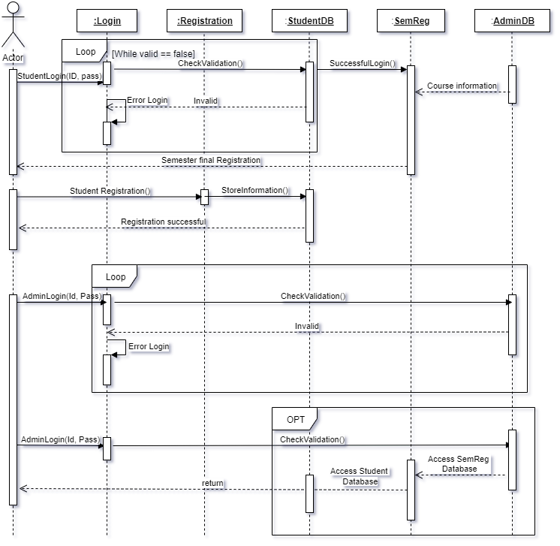

**Fig.** Sequence diagram.

**Conclusion:** From this lab I come to learn the sequence diagram. Our course teacher Mr. Tanvir Rahman sir has given the instruction to draw a sequence diagram of our project (Online Credit Fee Payment System). The sequence diagram shows the interaction between actor and database of the project.